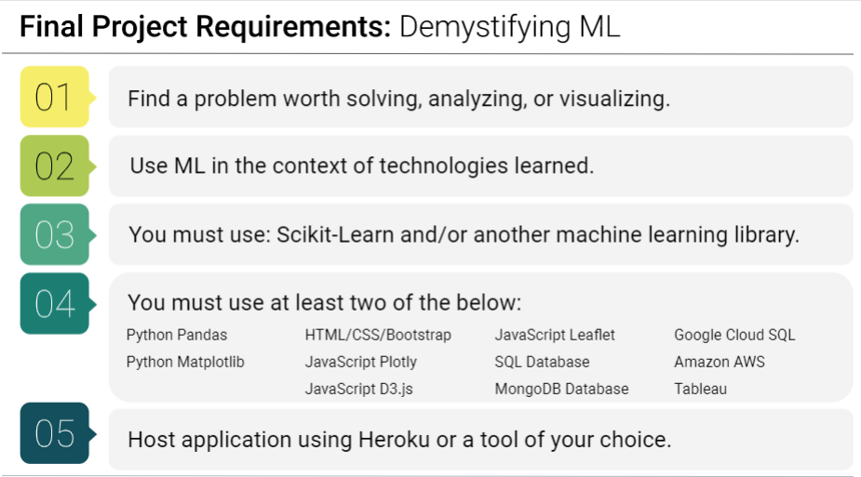

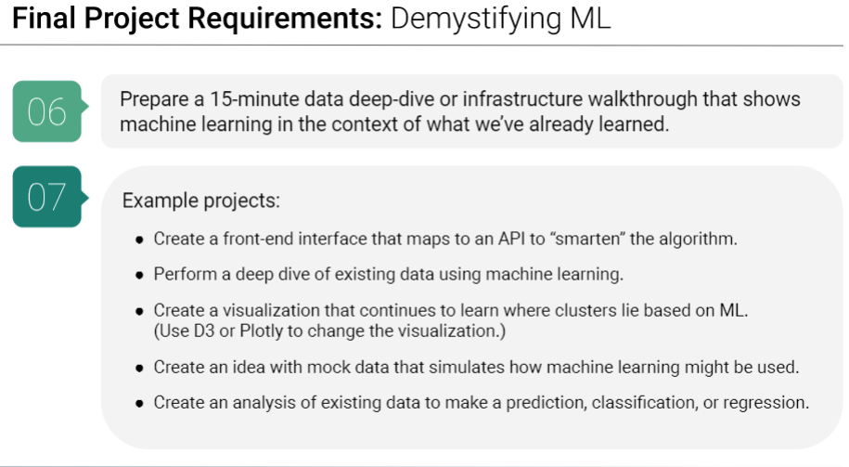

**Proposal One: State of Ohio Voter Polling**

Topic: Utilize dataset to determine how individuals will vote in congressional, state and Presidential elections in Ohio

Dataset: From employer based database based on social media survey/questionnaire. Small dataset, approximately 1,200 records.

Inspiration: To utilize a Decision Tree based ML to create a predictive model for elections occurring in Ohio for November 2020.

**Proposal Two: Shipwrecks of the Great Lakes**

Topic: Utilize weather data from buoys located in the Great Lakes alongside historical data of Great Lakes shipwrecks to predict conditions that can be hazardous to ships on the Great Lakes

Dataset: From buoy data <https://www.ndbc.noaa.gov/> for Great Lakes East and Lake Superior and a listing of Great Lakes shipwrecks <https://en.wikipedia.org/wiki/List_of_shipwrecks_in_the_Great_Lakes>.

Inspiration: To utilize a Decision Tree based ML to create a predictive model for conditions that would predict harsh conditions for ships on the Great Lakes.

**Proposal Three: Hurricane and Tropical Storm Severity in the Gulf of Mexico**

Topic: Utilize weather data from buoys located in the Gulf of Mexico and historical hurricane data to predict the severity of storms in the Gulf of Mexico.

Dataset: Based on buoy data of ten buoys located in the Gulf of Mexico from the period of 2005-2019 <https://www.ndbc.noaa.gov/> and a list of Continental Unites States Hurricane Impacts/Landfalls 1851-2019 <https://www.aoml.noaa.gov/hrd/hurdat/All_U.S._Hurricanes.html>

Inspiration: To utilize a Neural Network based ML to create a predictive model of the strengths of tropical storms and hurricanes.

**GROUP – Ruthy Amkraut, Megan Moroney & Rick Gentile**

* Ruthy Amkraut - @ramkraut
* Megan Moroney -
* Richard Gentile - [@rgentile21](https://github.com/rgentile21)